Ideation Phase Problem Statements

|  |  |
| --- | --- |
| Date | 12 October 2022 |
| Team ID | PNT2022TMID42038 |
| Project Name | Real-Time River Water Quality Monitoring and Control System |
| Maximum Marks | 2 Marks |

**Customer Problem Statement Template:**

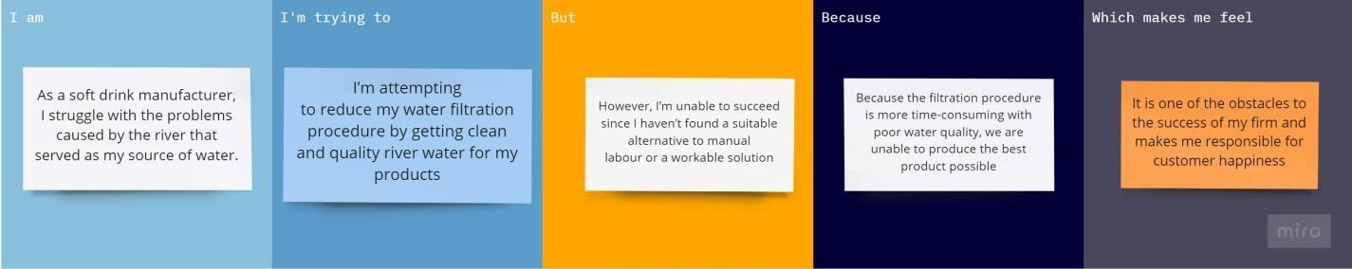

Reference: <https://miro.com/templates/customer-problem-statement/>

|  |  |  |  |  |  |
| --- | --- | --- | --- | --- | --- |
| **Problem**  **Statement (PS)** | **I am (Customer)** | **I’m trying to** | **But** | **Because** | **Which makes me feel** |
| PS-1 | As a soft drink manufacturer, I struggle with the problems caused by the river that served as my source of water. | I’m attempting to reduce my water filtration procedure by  getting clean and quality river water for  my products | However, I’m unable to succeed since I haven’t found a suitable alternative to manual labour or a workable solution | Because the filtration procedure is more time- consuming with poor water quality, we are unable to produce the best  product possible. | It is one of the obstacles to the success of my firm and makes me responsible for customer happiness. |
| PS-2 | I’m a  Limnologists | In order to do my research for my current thesis on river water management and its effects on ecosystems, I must evaluate the river's water quality. | But each time I require information about river water quality for analysis, I have to do it by hand, since I haven't discovered a good replacement to the  manual way | Because,  I can't do my task on time since evaluating the river water quality takes additional time. | It gives me the impression that, in order to finish my thesis quickly, I need an automated river water management and control system that will allow me to use the data it generates for  my research. |